
ASSIGNMENT No :3
TITLE :Develop a Java application demonstrating method overloading and the use of static variables, methods in class design.
Problem Statement
Develop a Java application demonstrating method overloading and the use of static variables, methods in class design.
Learning Objectives
To implement method overloading and use static variables and methods in Java programs.
Theory
Method overloading allows multiple methods to have the same name with different parameter lists, enabling compile-time polymorphism. The static keyword is used for variables and methods that belong to the class instead of individual objects. Static members share common data among all objects and reduce memory usage. These concepts improve code flexibility, readability, and efficient resource management.
Outcome
1)Understood the concept of method overloading and implemented overloaded methods for different data types.
2) Learned the use of static variables to share common data among all objects of a class.
3) Gained knowledge of static methods and their role in class-level operations.
4)Improved understanding of compile-time polymorphism and object-oriented programming concepts in Java.
Conclusion
The experiment successfully demonstrated the implementation of method overloading and the use of static variables and methods in Java. Method overloading provided flexibility by allowing multiple methods with the same name but different parameter lists, while static members enabled data sharing and class-level functionality without requiring object-specific storage. Thus, the experiment enhanced the understanding of important object-oriented programming concepts and their practical applications in Java.

Exercise
- Develop a Calculator program using overloaded methods for addition of integers and decimals. Use a static variable to count calculations

CODE:
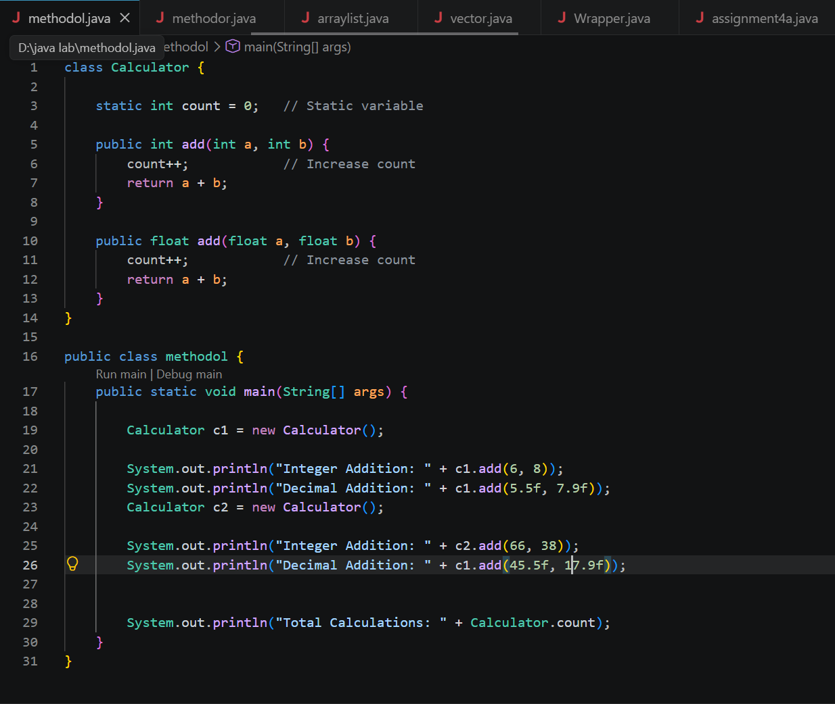

OUTPUT:
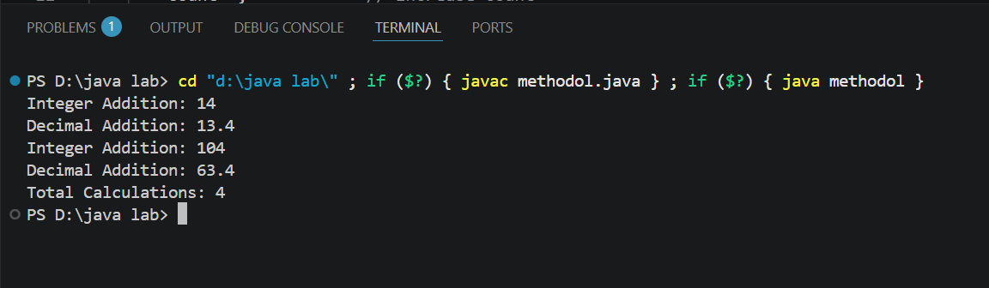
- Develop a Restaurant Billing Application where overloaded methods calculate bills for dine-in, takeaway, and delivery orders, while static variables track total orders

CODE:
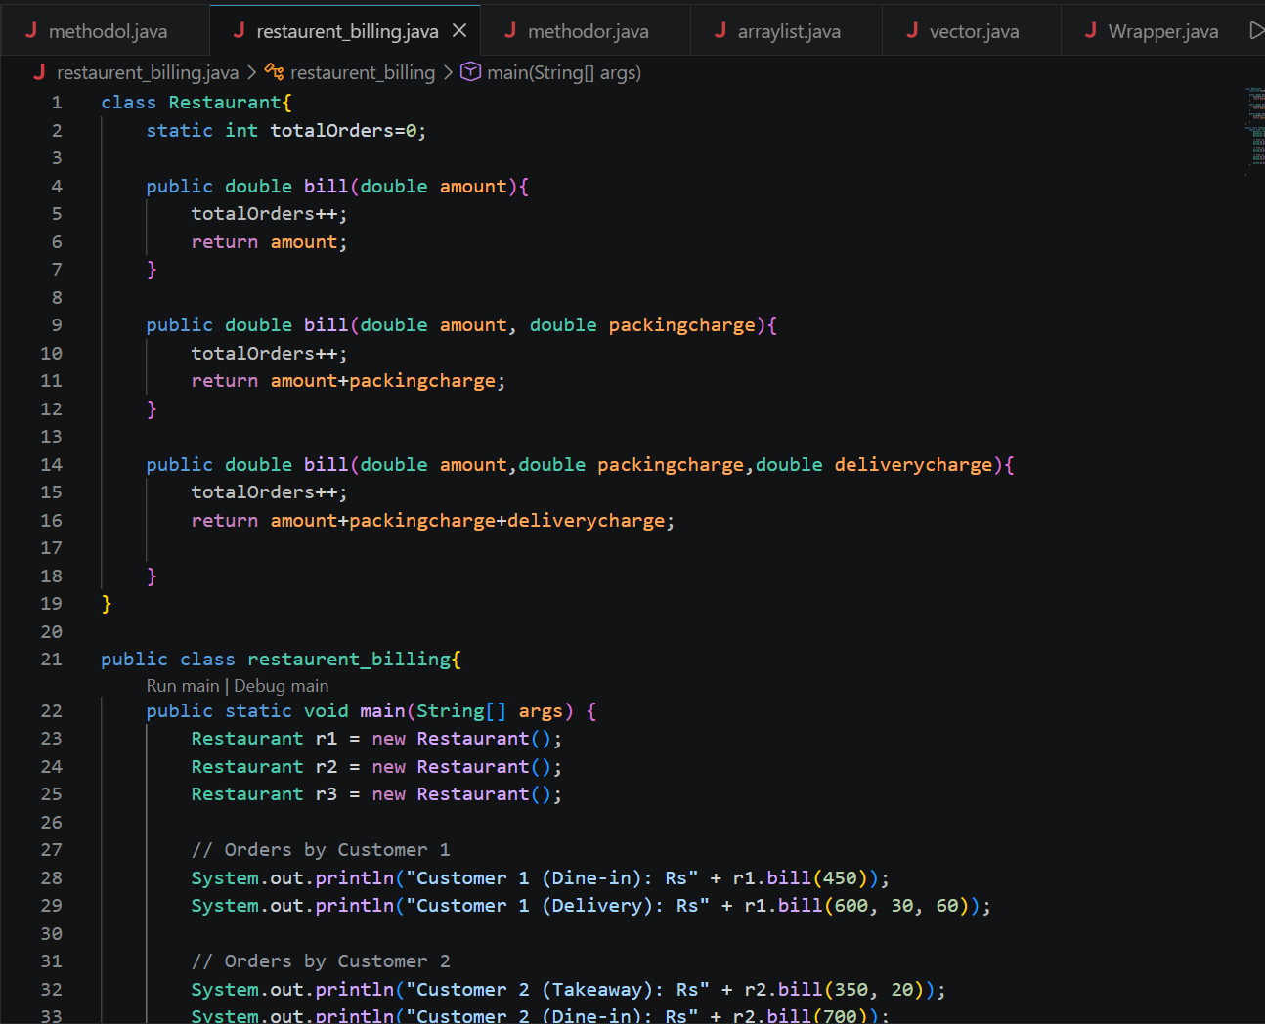
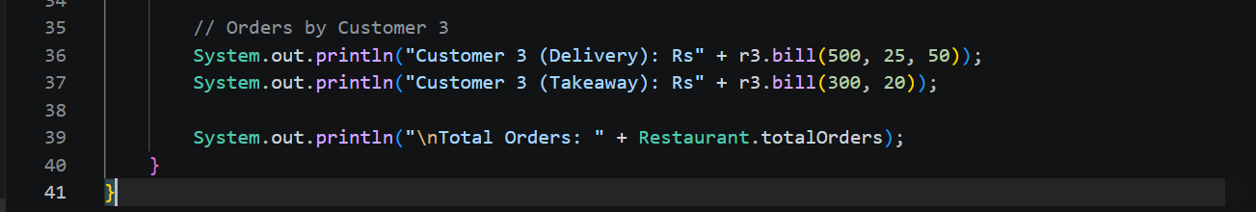

OUTPUT:
